**EXTERNAL JS**

***SOURCE CODE:***

<!DOCTYPE html>

<html lang="en">

<head>

<meta charset="UTF-8">

<meta http-equiv="X-UA-Compatible" content="IE=edge">

<meta name="viewport" content="width=device-width, initial-scale=1.0">

<title>Externl JS</title>

</head>

<h3>EXTERNAL JS</h3>

<p>The image is moving from left to right gradually</p>

<script src="External.js"></script>

<body>

<img id="myImage" src="C:\Users\adhis\OneDrive\Desktop\Mr.Bean.png"

style="position: absolute;

top: 100px; left: 0;">

</body>

</html>

***JS CODE:***

window.onload = function() {

var image = document.getElementById("myImage");

var position = 0;

var speed = 2;

function moveImage() {

position += speed;

image.style.left = position + "px";

if (position >= window.innerWidth - image.width) {

clearInterval(intervalid);

}

}

var intervalid = setInterval(moveImage, 10);

};

***OUTPUT:***

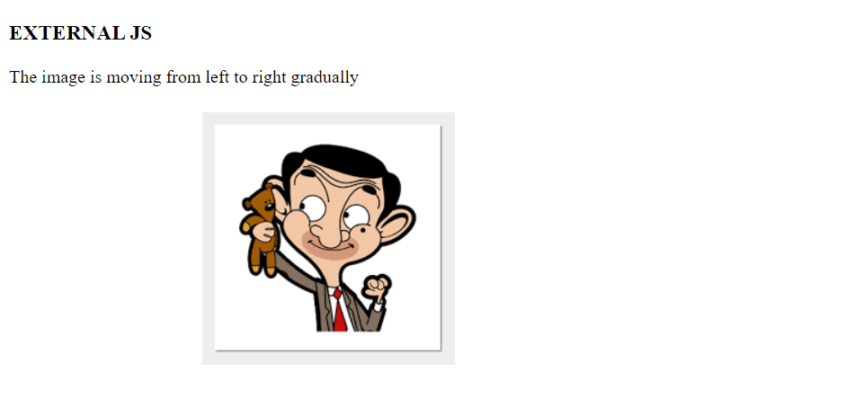

**INTERNAL JS**

***SOURCE CODE:***

<!DOCTYPE html>

<html lang="en">

<head>

<meta charset="UTF-8">

<meta http-equiv="X-UA-Compatible" content="IE=edge">

<meta name="viewport" content="width=device-width, initial-scale=1.0">

<title>Internal js</title>

</head>

<body>

<h3>INTERNAL JS</h3>

<p>Click on show image button to see the image</p>

<button onclick="displayImage()">Show Image</button>

<img id="myImage" src="C:\Users\adhis\OneDrive\Desktop\Mr.Bean.png" style="display: none;">

<script>

function displayImage() {

var image = document.getElementById("myImage");

image.style.display = "block";

}

</script>

</body>

</html>

***OUTPUT:***

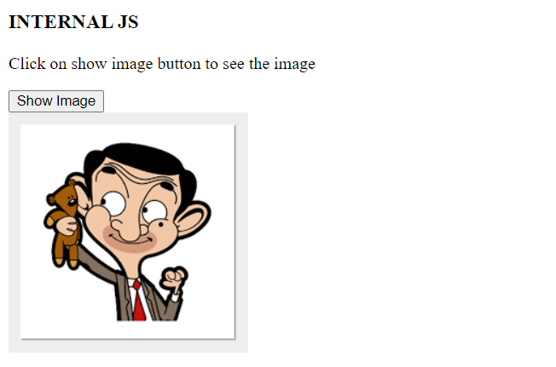

**INLINE JS**

***SOURCE CODE:***

<!DOCTYPE html>

<html lang="en">

<head>

<meta charset="UTF-8">

<meta http-equiv="X-UA-Compatible" content="IE=edge">

<meta name="viewport" content="width=device-width, initial-scale=1.0">

<title>Inline JS</title>

</head>

<body>

<h3>INLINE JS</h3>

<script>

var sum="a+b";

var sub="a-b";

var mul="a*b";

var div="a/b";

a=40,b=5;

document.write("The addition is "+(a+b));

document.write("The subtraction is "+(a-b));

document.write("The multiplication is "+(a*b));

document.write("The division is "+(a/b));

</script>

</body>

</html>

***OUTPUT:***

